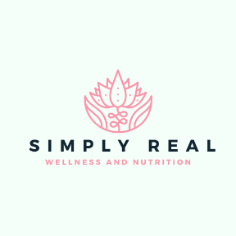
Simply Real Wellness and Nutrition
Comp Session Questions
Date:______________________
Name:________________________
Age:_____________________
Tell me a little about yourself….
Give me a quick sketch of who you are.

What major changes have you been faced with over the last couple of years?

List 5 things that you feel you are ‘putting up with’ right now?
1.

2.

3.

4.

5.

What 3 “health” goals do you want to achieve within the next 3 months?
1.

2.

3.

What is most important to you in your life and why?

What is the greatest challenge you have had to overcome?

What is your favorite food and why?

What led you to want to pursue a coaching relationship? Is there anything else you would want to know about a coaching relationship?

